**Summary report with key insights and recommendations**:

**Purpose of the Report:**

* Evaluating performance over a specific period
* Analyzing trends
* Investigating any anomalies or outliers
* Providing actionable business recommendations

**Data Collection and Analysis**

Here are some key analysis tasks:

1. **Descriptive Statistics**:
2. Product Category 5
3. Product Name 620
   * The data provided consists of 1005 columns and 8 rows
   * Here we have 5 product category and 620 product name
   * Trends and seasonality.i.e.,trends shows that in the month of January sell goes down that means January has lowest sell and by the trend it is observed that February holds the highest sell.
4. **Visualize the Data**:
   * Time series charts between month and total revenue and to easily communicate patterns.
5. **Identify Key Insights**:
   * Are there any unexpected changes in sales in January and February
6. **Identify any Issues or Anomalies**:
   * Outliers had be encountered in Total Revenue
   * Total Revenue consists of missing values which I have filled with mean values.

**Report Structure**

**1. Title and Introduction**

* **Title**: *"Monthly Sales Summary and Insights – January 2024-2025"*

**2. Key Metrics and Findings**

Summarize the important numbers and key insights.

Example:

* **Total Revenue**:254615.17 in February 2024
* **Top Performing Product**: Apple (Total sales: $30,000)
* **Average Sales per Day**: $3,200
* **Month-on-Month Growth**: 296.31% increase in sales compared to January and february 2024

**3. Visual Representations (Charts and Graphs)**

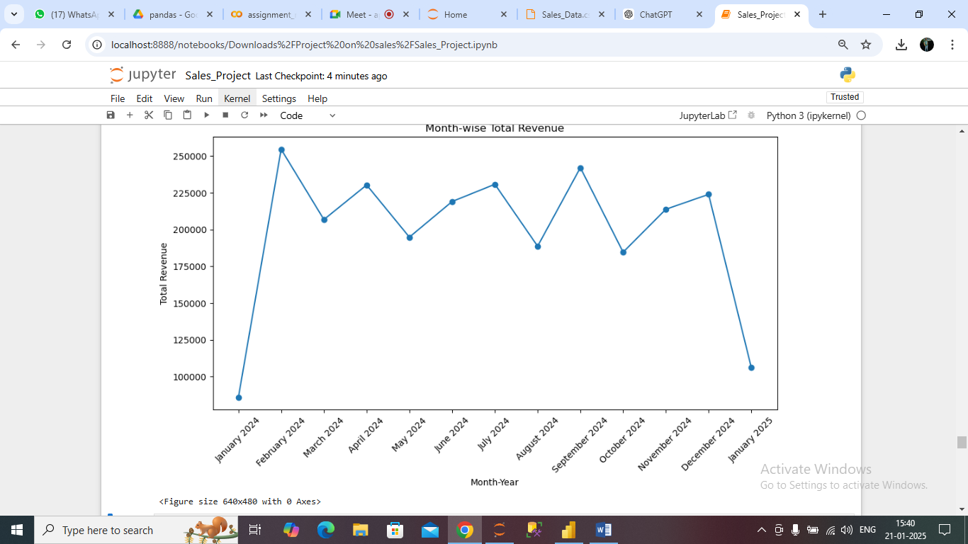

* Include relevant charts that summarize key findings.
  + **Sales Trend Over Time**
  + **Top-Selling Month**
  + **Monthly Sales Breakdown**
  + **Example:**

# Plotting the month-wise total revenue with 'Month_Year' as the x-axis

plt.figure(figsize=(10, 6))

plt.plot(monthly_revenue['Month_Year'], monthly_revenue['Total Revenue'], marker='o')

plt.xlabel('Month-Year')

plt.ylabel('Total Revenue')

plt.title('Month-wise Total Revenue')

plt.xticks(rotation=45)

plt.tight_layout()

# Display the plot

plt.show()

plt.savefig('line_chart.pdf')

**4. Key Insights**

Highlight any significant findings in the data.

Example:

* Sales increased by 296.31% increase in sales compared to January and February 2024.

**5. Challenges or Issues**

Discuss any data anomalies, issues, or unexpected findings.

Example:

* Data inconsistency was found in **Total Revenue**, where several entries were missing.
* **Grapes** showed an unexpected decline in sales in the December 2024 and January 2025, potentially due to seasonal variations.

**6. Recommendations**

Based on the insights, provide actionable recommendations.

* **Focus Marketing on High-Selling Products**: Prioritize marketing efforts for products to maximize sales.
* **Investigate Low-Performing Products**: Look into why Products underperformed and explore product quality or seasonal factor.

**7. Conclusion**:

* The report highlights the strong sales growth in February 2024. However, there are some challenges to address regarding low sales on weekends and the performance of certain products. By taking the recommended actions, we can improve future sales.